ZOMATO PROJECT

-KRISHI RAJ

**Objective Questions:**

1. The data consists of some inconsistent and missing values so ensure that the data used for further analysis is cleaned.

ANS:

**Replacing missing values:**There were few missing values in cuisine column ,I could find an effective way to replace those so I have deleted those 9 records which didn’t hamper my analysis a lot.

**Formating date column:**

The date column wasn’t getting formated with the format option in ribbon,so I first replace underscore with – and then changed it to proper date format.

Extracted year column using year function.

Also changed cost for two value into inr for sujjested countries using vlookup function and multiplication operation.

2.**Using the LookUp functions, fill up the countries in the original data using the country code.**

**ANS:**Thevlookup formula I have used is as follows:

=VLOOKUP(C735,'country description'!$A$2:$B$16,2,0)

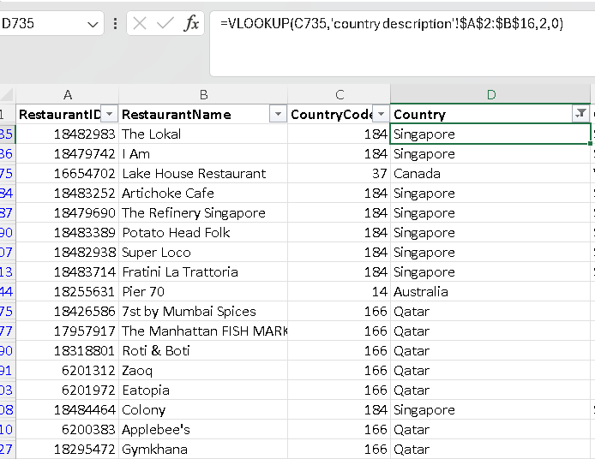

**3.Create a table to represent the number of restaurants opened in each country.**

**ANS:**

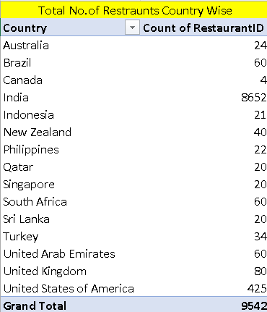

**4.Also, the management wants to look at the number of restaurants opened each year, so provide them with something here.**

**ANS:**For this I have created a pivot table with year as rows and restraunt id in values as count.

**5.** **What is the total number of restaurants in India in the price range of 4?**

**ANS:**I have used countifs formula to answer this question.

**The formula is as follows:**

=COUNTIFS('Raw Data'!$D$2:$D$9543,'Raw Data'!$D$2,'Raw Data'!$Q$2:$Q$9543,"=4")



**6.According to the data, what is the average number of voters for the restaurants in each country?**

**ANS:**To answer this question I have created a pivot table with country as rows and votes in values calculated as average.

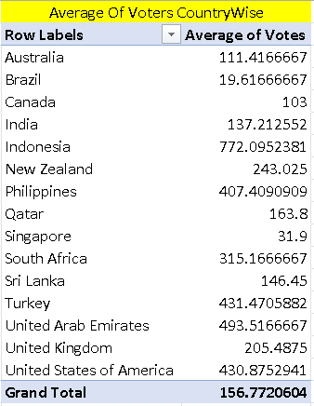

**Subjective Questions:**

1. Suggest a few countries where the team can open newer restaurants with lesser competition. Which visualization/technique will you use here to justify the suggestions?

**Ans**: I inserted a pivot table for this question from the cleaned data .Selected the country column and restauntid,rating,votes in values to be calculated as count,average and sum respectively..Then I also inserted a column chat to analyze the same.

**Observation**:According to my analysis and observations on the pivot table I felt the countries with lower restraunt count would be a good option.Then I also considered average rating,sum of votes to suggest some countries.I observed **Australia, Canada and Singapore** were the nations with low restraunt count and the average rating is also around 3.5 where it seems of a great potential growth for the business.

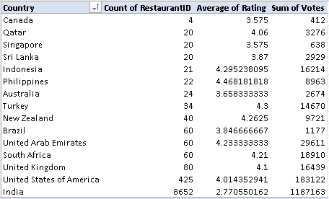

1. Come up with the names of States and cities in the suggested countries suitable for opening restaurants.

**Ans**: I created a pivot table with country,city,count of restraunt id,average of rating columns .For the country with multiple cities I made a decision of selecting the cities that were having a rating less than the average rating of the country as the scope to business is more on providing great services.

**The suggested cities are as follows:**

* **Australia:** Balingup, Mayfield, Montville, Paynesville, Penola
* **Canada:** Consort, Yorkton
* **Singapore:** Singapore

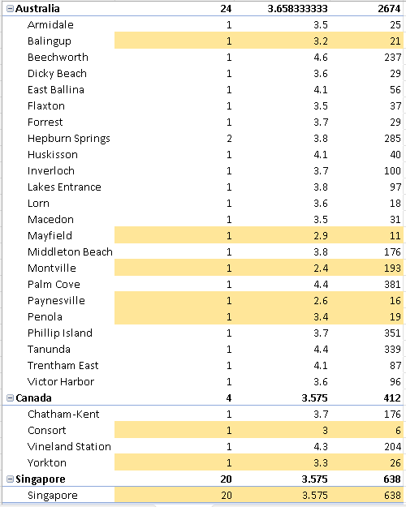

1. According to the countries you suggested, what is the current quality regarding ratings for restaurants that are open there?

**Ans**:I have created a pivot table filtering out the countries that were suggested and used a column chart to visualise the same .

**Observation:**

I have observed the ratings to be in a range of 3.5 average. Which I feel indicate a good to moderate ratings but can be improved by providing great service and taste.

Australia has highest avg rating of 3.66 approx. followed by canada and singapore to have 3.575.

**4.** **Also, what is the current expenditure on food in the suggested countries, so we can keep our financial expenditure in control?**

**Ans:** I created a table of countries and average total amount spent on food for 2 by using sumif condition then used a pie chart to visualize the same in the dashboard.

**The total expenditure mentioned is Indian Rupees(INR).**

**Observations:**

* Singapore spends a lot on food and the data is also aggregated for only one mentioned city with 20 restaurants.
* Singapore can be our primary option as we are assured to get some share of the market available.
* Australia can be our secondary choice as it has the next highest expenditure followed by singapore.

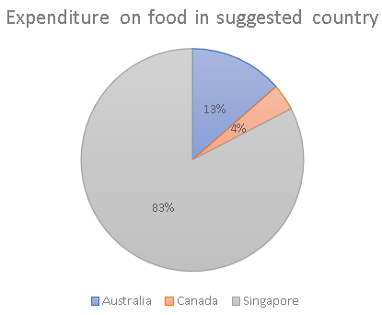

**5.Come up with the names of restaurants from the recommended states that are our biggest competitors and also those that are rated in the lower brackets, i.e. 1-2 or 2-3.**

**Ans:**To understand the competition level from different restaurants I have created 3 different pivot tables one ech for the three suggested countries with restraunt name and average rating of the restaurant.

I have indicated the restaurants with highest competition as red colour indicating a competition ,orange for moderate competition and yellow for leat expected to give a competition to us.

The observed restraunts in the range of 1-3 are as follows:

* **Australia-** Pier 70, Poets Cafe, Star Buffet
* **Canada-** Consort Restaurant
* **Singapore-** Makansutra Gluttons Bay

**6.Which cuisines should we focus on in the newer restaurants to get better feedback? Does the choice of cuisines affect the restaurant ratings?**

**Ans:**

I created a pivot table with countries,cusines in rows and rating aggreagted as average values.Filtered the countries suggested by applying filter on countries, and aslo selcted only those cusines with rating greater than 4.

My observation is the restraunts in australia are more focused on local cuisines.Where as the other countries restraunts focus on international cuisine more and italian food in specific.

In general Australian,Italian,Mediterranean and Bakery food can be preffered.

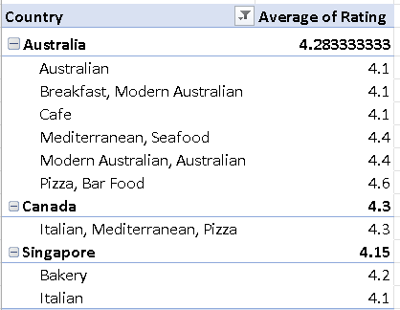

**7. According to our current data, should we go for online delivery and table booking? Does that affect the customer’s ratings?**

Ans:

I used countifs function to analyse the trend of online delivery and table booking to create a table.

I have also used pivot tables to understand the effect of availability of these services over rating for the restaurants for all countries as suggested countried don’t have any of these services.

**Observation:**

The observation I had was that none of the suggested countries was having online delivery and table booking. Additional features like these would really be helpful to grow the business.The restraunts having these facilities also tend to have a slight higher average rating in comparision.

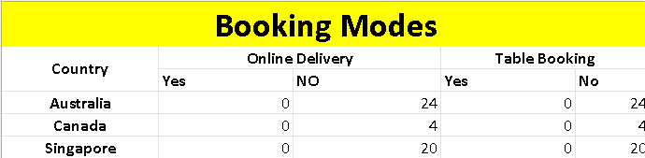

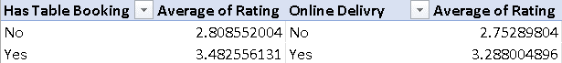

**8. Should the team keep the rate of cuisines higher? Will that affect the feedback? According to our data are the rates of cuisines and ratings, correlated?**

Ans:

I used the correl formula to understand the relation between rates of cuisines and ratings. I have created a line chart to analyse the same.

**Observation:**

I found it to be close to zero but not exactly.We can assume the rating and prices have an slight impact on each other.

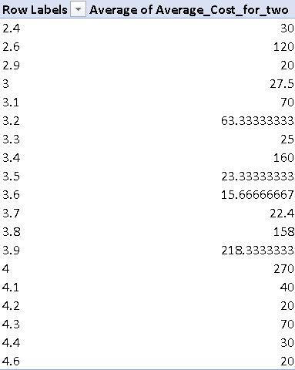

**9. What is the distribution of a number of restaurants of different price ranges in all the countries?**

**Ans:**

I created a pivot table with countries in rows,price range in columns and restraunt id to values as count aggregation.

I inserted a surface chart (pivot chart ) to visualise the same.

**Observations:**

* **Most countries have less restaurants in price range 0f 4.**
* **In case of suggested countries Singapore has more restaurants in price range of 4,but Australia and Canada have their majority restaurants in price range 2,3.**



